Little SPARK: Simple Play Adaptations to Reference for Kids

Tic Tac Toe Built-In Switch Game
Description: | Image:
This adapted version of Tic Tac Toe is 11"L x 13½"W x 9½"H. It weighs 2 ¼ pounds and requires four AA batteries.  Purchasing Information  User’s Manual | 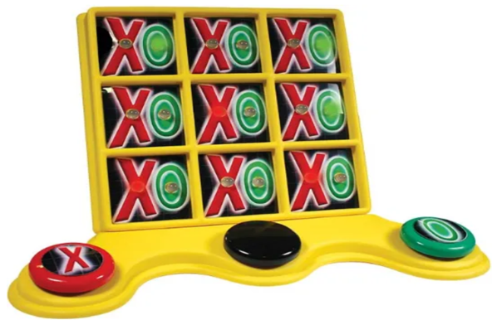

Who Might Benefit?
Those who benefit from accessible, engaging, and visually/auditorily stimulating activities that support cause-and-effect learning, motor skill development, peer interaction, and participation despite fine motor, visual, or mobility challenges.
Why Use?
Provides an opportunity to support the development of switch use, scanning skills, problem-solving, cooperative play, and participation in traditional games without requiring fine motor control or writing tools.
Instructions for Use: | Adaptation Ideas:
Environmental Considerations  - Use in any environment including community, home, and school on a flat surface.  Positioning  - Use in seated position at a table or on the floor, standing at a table, or lying on the floor.  Basic Play/Use  - Players choose “X” or “O”, when a player gets three in a row, the lights on the adapted game board will flash and music will play.  Extended Play/Use  - Use as a counting game, counting shapes, scanning activity, or a choice board.  Play/Use with Others  - Give each child a turn, develop social scripts for turn taking, model my turn/your turn. | Build It Up  - Enlarge switch surface with textured fabric.  Stabilize It  - Encourage the child to rest their forearm on the table while engaged in the activity.  - Use Dycem under the item or attach Velcro.  Add Sensory Cues  - Apply various textures (e.g. Velcro, Dycem, shelf liner) to switch surfaces to add tactile interest.  Communication Support  - Guide possible sections with pointing, develop social scripts for turn taking.  DIY Alternatives  - Trial different switches, or compare to traditional paper and pencil.

Words to Encourage Play/Use
Look  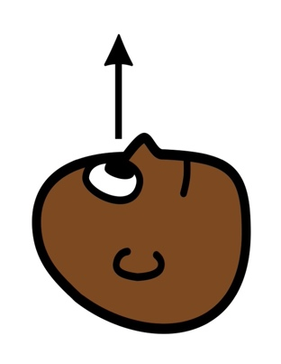 | Find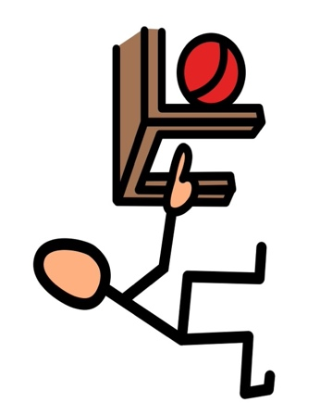 | Push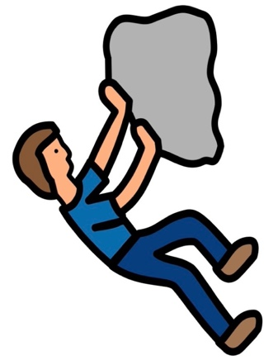
Stop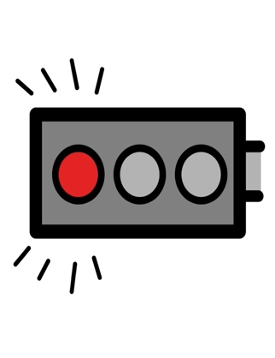 | Go | Done  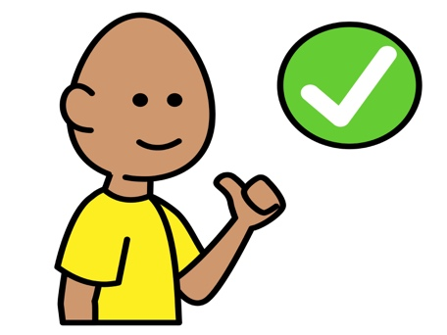
Your turn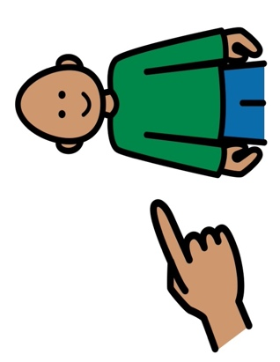 | My turn  | Wait  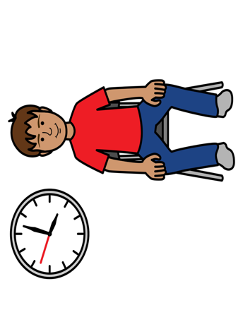
*”Adaptations” adapted from: Haugen’s Modes for Adapting Toys based on materials from the "Let's Play" Project at the University of Buffalo
PCS is a trademark of Tobii Dynavox, LLC. All rights reserved. Used with permission.

